|  |  |
| --- | --- |
| Canon EOS R6 + Lens 24-105mm f/4-7.1  Máy ảnh Canon EOS R6 + Lens 24-105mm f/4-7.1  Canon EOS R6 with 24-105 f4-7.1 lens 2 Canon EOS R6 6 Canon EOS R6 7 Canon EOS R6 4 | **Featured information:**  DIGIC X image processor  20MP full-frame CMOS sensor  5-axis image stabilization  Record 10-bit 4K60p and FHD 120p video  Price: $2000  **Specifications:**  Lens Mount  Canon RF  Sensor Format  Full-Frame (1x Crop Factor)  Resolution  20.1 Megapixels  Size photo  5472 x 3648  Image Proportions  3:2  Sensor Type  CMOS  Image Format  JPEG, Raw, HEIF  Anti-Vibration  Sensor-Shift, 5-Axis |

**Overview:**

Canon EOS R6 is a Canon camera equipped with a 20.1 megapixel Full-frame CMOS sensor, which has been improved compared to the same sensor found on the 1DX mark III professional DSLR line. Combined with the DIGIC

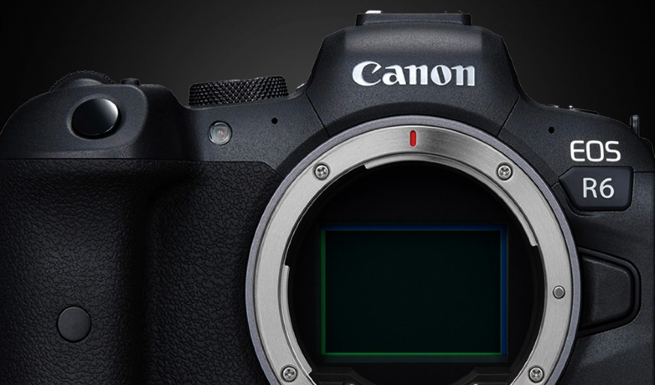

The Canon EOS R6 supports an ISO range of 100 – 102400, expandable up to 204800. The camera allows rapid continuous shooting at up to 12 frames per second with the mechanical shutter, or 20 frames per second with the electronic shutter. , offers silent shooting, ideal for working in quiet environments.

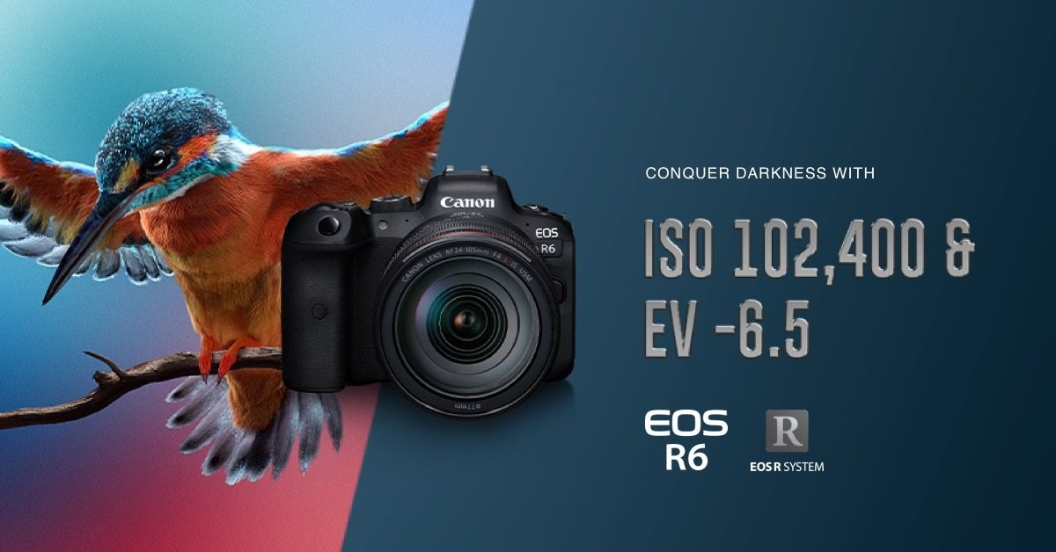

In addition to taking high-quality photos, the 20MP sensor of the Canon EOS R6 Full-frame mirrorless camera also supports 10-bit video recording with a ratio of 4:2:2 in UHD 4K quality at a speed of up to 60 frames per second and Full HD at 120 fps. Both formats can be shot with Canon Log and HDR-PQ modes that support greater control over color rendering and provide high dynamic range.

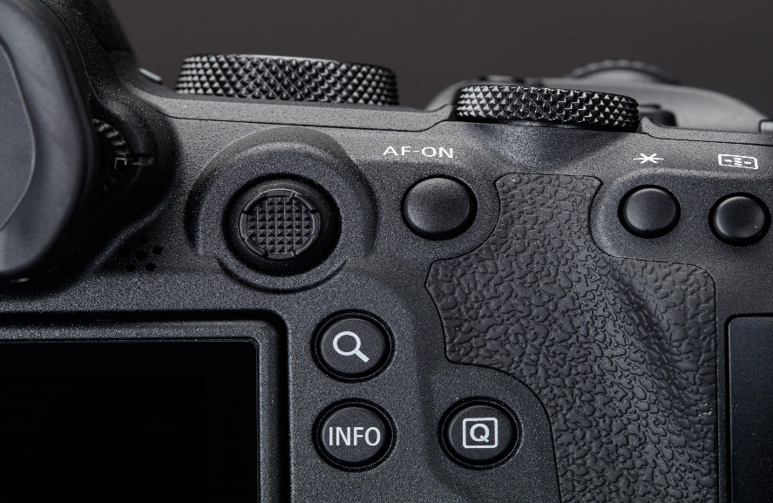

Dual Pixel CMOS AF II offers 1053 selectable AF points, helping the Canon EOS R6 autofocus and track subjects quickly and accurately, with approximately 100% frame coverage. Additionally, when recording video, Movie Servo AF mode provides smooth and natural focusing when there are changes in focus subjects, or changes in distance due to subject movement.